**Change Password or Recover Forget Password**

Open Services

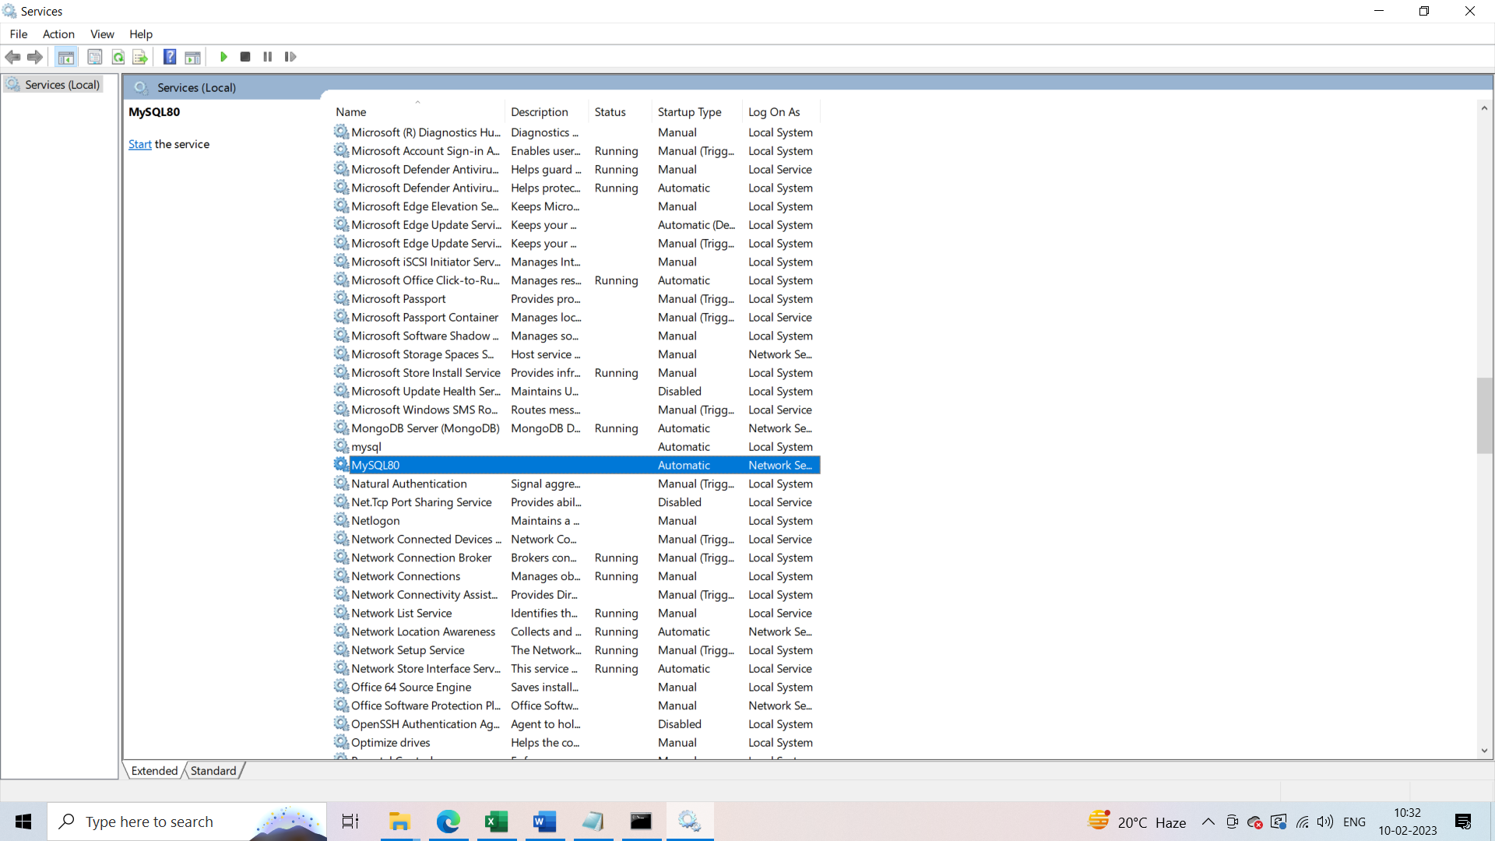

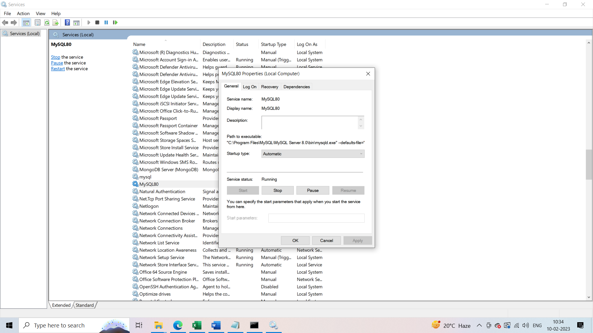

Stop the MySQL80 service and then Right Click on the path and click on select all option

Copy the path “"C:\Program Files\MySQL\MySQL Server 8.0\bin\mysqld.exe" --defaults-file="C:\ProgramData\MySQL\MySQL Server 8.0\my.ini" MySQL80”

Now, Type command in txt file and save in c drive with name reset.txt:

Alter USER 'root'@'localhost' identified by '12345';

Open cmd and type following command

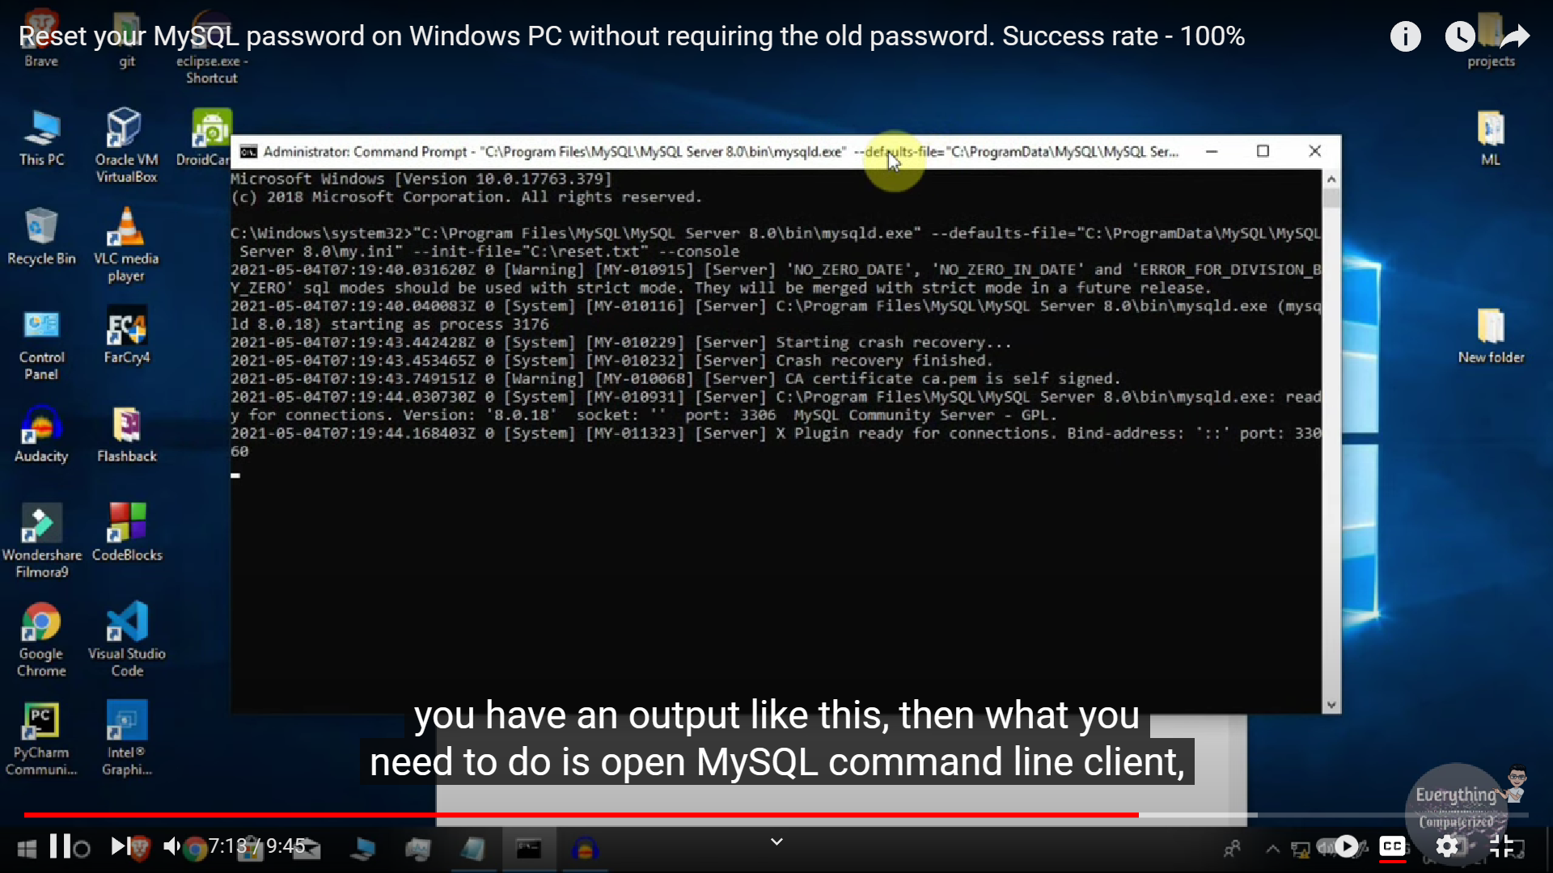

"C:\Program Files\MySQL\MySQL Server 8.0\bin\mysqld.exe" --defaults-file="C:\ProgramData\MySQL\MySQL Server 8.0\my.ini" --init-file="D:\reset.txt" --console